PROJECT DOCUMENTATION – WEATHERWISE AI

Project Title – WeatherWise AI – Deliver Intelligent Weather Forecasts and Insights.

Team ID – SWTID-2026-6359

Team Leader – Raj Kumar M - manivannan30091980@gmail.com

Team Members – Pasupathi M - pasupathimaster@gmail.com
Prathish R - praveenprathish123@gmail.com
Rachin K - rachinrachin194@gmail.com

PROJECT OVERVIEW
WeatherWise AI is an intelligent weather platform designed to provide real-time weather information along with AI-powered summaries and personalized recommendations. The system combines weather data with Google Gemini AI to help users understand current environmental conditions in a simple and useful way.
The backend is developed using Node.js, Express.js, MongoDB, and Mongoose, with JWT authentication and password hashing for security. The platform allows users to manage favorite locations, retrieve weather information, and receive AI-generated weather insights. Main objective: To provide users with intelligent weather forecasts, easy-to-understand weather summaries, and personalized recommendations based on current weather conditions.

1. Brainstorming & Ideation Phase

1.1 Project Idea

WeatherWise AI is an AI-powered weather assistance platform designed to simplify the way users understand weather conditions. The project combines a RESTful backend with Generative AI to retrieve weather information and generate useful summaries and recommendations.

1.2 Scenario-Based Case Study
Alex is a travel enthusiast who frequently visits different cities and needs to monitor local weather conditions before planning his activities. He wants a simple platform that can provide current weather information and explain the conditions in an understandable way.
Traditional weather applications mainly display temperature, humidity, wind speed and other raw weather metrics. Users may need to interpret these values themselves and decide whether the conditions are suitable for travelling, outdoor activities or particular clothing. WeatherWise AI addresses these difficulties through a centralized AI-powered weather platform that combines real-time weather information with intelligent recommendations.

1.3 Problem Identification
- Difficulty monitoring multiple favourite weather locations.
- Raw weather metrics can be difficult for some users to interpret.
- Lack of personalized recommendations for outdoor activities and clothing.
- Need for natural-language weather summaries.
- Requirement for a secure system to store user accounts and favourite locations.
- Switching between different weather and information sources can reduce convenience.

2. Problem Statement and Objectives

2.1 Problem Statement
- Weather information is often displayed as raw numbers that users must interpret.
- Users may need to monitor several cities or favourite locations.
- Conventional weather displays may not provide personalized activity or clothing guidance.
- Users need secure storage for accounts and preferences.
- The backend should remain modular, maintainable and testable.

2.2 Objectives
- Provide real-time weather metrics through REST APIs.
- Generate natural-language weather summaries using AI.
- Provide personalized recommendations based on current conditions.
- Allow authenticated users to maintain favourite locations.
- Use password hashing and JWT-based authentication.
- Persist users and locations using MongoDB and Mongoose.
- Provide API responses that can be tested with API testing tools.

3. Scenario-Based Case Study

3.1 Background
A travel-oriented user such as Alex frequently visits different cities and needs one service to check local weather conditions and receive useful AI-driven suggestions.

3.2 Existing Problems
- Managing several favourite cities can be inconvenient.
- Raw temperature, humidity and wind values may require interpretation.
- Generic weather information may not answer practical questions.
- Clothing and outdoor-activity guidance may be missing.
- Preferences need secure storage and synchronization.

3.3 Proposed Solution
- User registers or logs in.
- The server validates credentials and issues an authenticated token.
- The user can save or retrieve favourite locations.
- The weather API returns current metrics for a city.
- The AI summary converts metrics into natural language.
- The recommendation API provides practical guidance.
- The server returns structured JSON responses.

4. System Requirements

4.1 Software Requirements
Software / Tool | Purpose
Windows 10/11, macOS or Linux | Operating environment
Node.js v16+ | Server-side runtime
npm v8+ | Dependency management
Express.js | REST API and routing
MongoDB + Mongoose | Data persistence and ODM
Google Gemini AI SDK | AI summaries and recommendations
Postman / Thunder Client | API testing
Visual Studio Code | Development environment

4.2 Hardware Requirements
- Processor: Intel Core i5 8th Gen / AMD Ryzen 5 or equivalent.
- RAM: 8 GB minimum; 16 GB recommended.
- Storage: approximately 1 GB available workspace.

4.3 Environment Variables
PORT=5000
MONGO_URI=your_mongodb_connection_string
JWT_SECRET=your_jwt_secret
GEMINI_API_KEY=your_gemini_api_key

5. Project Architecture

5.1 Architecture Pattern
WeatherWise AI follows an MVC-oriented backend structure. The Model layer manages MongoDB data through Mongoose. The Controller layer processes request and coordinates services. In this headless backend, the View responsibility is represented by the API routing layer.

5.2 High-Level Flow
Layer | Responsibility
Client / API Tool | Sends HTTP requests and displays JSON responses
Express Server | Routes requests, parses JSON and handles CORS
Middleware | Authentication, authorization and input protection
Controllers | Validate requests and coordinate operations
Services | Weather retrieval and AI generation
Mongoose / MongoDB | Stores users and favourite locations

5.3 Key Components
- Express Server Gateway
- JWT Authentication Middleware
- Weather Service
- Gemini AI Service
- Mongoose Database Interface

6. Database Design

6.1 User Entity
Field | Type / Rule
_id | Object ID, Primary Key
name | String, Required
email | String, Required, Unique
password | String, Hashed, Required
role | String, default reader

6.2 Location Entity
Field | Type / Rule
_id | Object ID, Primary Key
user | Reference to User
city | String, Required
country | String, Required
created At | Date, default current time

6.3 Relationship
One registered User can have many favourite Location records. Therefore, the User-to-Location relationship is one-to many.

6.4 Data Protection
- Passwords are hashed.
- Email uniqueness is enforced.
- Mongoose validates document structure.
- JWT protects authenticated operations.
- Request sanitization reduces unsafe input.

7. Functional Modules and API Design

7.1 Authentication Module
Registration creates a user record with a hashed password. Login verifies credentials and returns a JWT token used for protected operations.

7.2 Weather Module
The weather module returns structured information such as city, temperature, humidity, wind speed, weather condition and the is Mock indicator.

7.3 AI Summary Module
The summary endpoint converts weather metrics into a short natural-language explanation so that users can understand the current conditions more easily.

7.4 Recommendation Module
The recommendation endpoint uses weather information to generate practical suggestions such as hydration, clothing or outdoor-activity guidance.

7.5 API Summary
Module | Operation | Purpose
Auth | Register / Login | Account and JWT authentication
Weather | GET | Current weather metrics
Summary | POST/GET | AI weather explanation
Recommendation | POST/GET | Practical weather advice
Locations | CRUD | Manage favourite cities

8. Project Setup and Configuration

8.1 Setup Steps
- Create a project folder named AI Weatherwise.
- Open the folder in Visual Studio Code.
- Initialize the Node.js project.
- Install the required backend packages.
- Create the environment configuration file.
- Create the entry point and modular folders.
8.2 Initialization Commands
npm init -y npm install express mongoose bcryptjs jsonwebtoken cors dotenv multer @google/genai npm install --save-dev nodemon npm install
npm start

8.3 Suggested Folder Structure

AI Weatherwise/
├── index.js
├── .env
├── package.json
├── .gitignore
├── routes/
├── controllers/
├── models/
├── middleware/
└── services/

9. Backend Implementation

9.1 Application Entry Point
The index.js file is the main entry point. It loads environment variables, configures Express middleware, connects to MongoDB, registers API routes and starts the server after a successful database connection.

9.2 Request Processing Flow
- Client or API testing tool sends an HTTP request.
- Express receives the request and applies middleware.
- JWT middleware validates protected requests.
- The controller validates and processes the request.
- The weather service retrieves or prepares weather data.
- The AI service generates summaries or recommendations.
- Mongoose communicates with MongoDB when persistence is required.
- The server returns a structured JSON response.

9.3 AI Integration
The reference specifies Google Gemini integration through the Google generative AI SDK. The AI layer uses weather information to generate natural-language summaries and personalized recommendations.

9.4 Fallback and Error Handling
The reference describes a fallback mode for continued API functionality when external API keys are unavailable, together with centralized error handling and request sanitization.

10. API Testing and Demonstration

10.1 Testing Environment
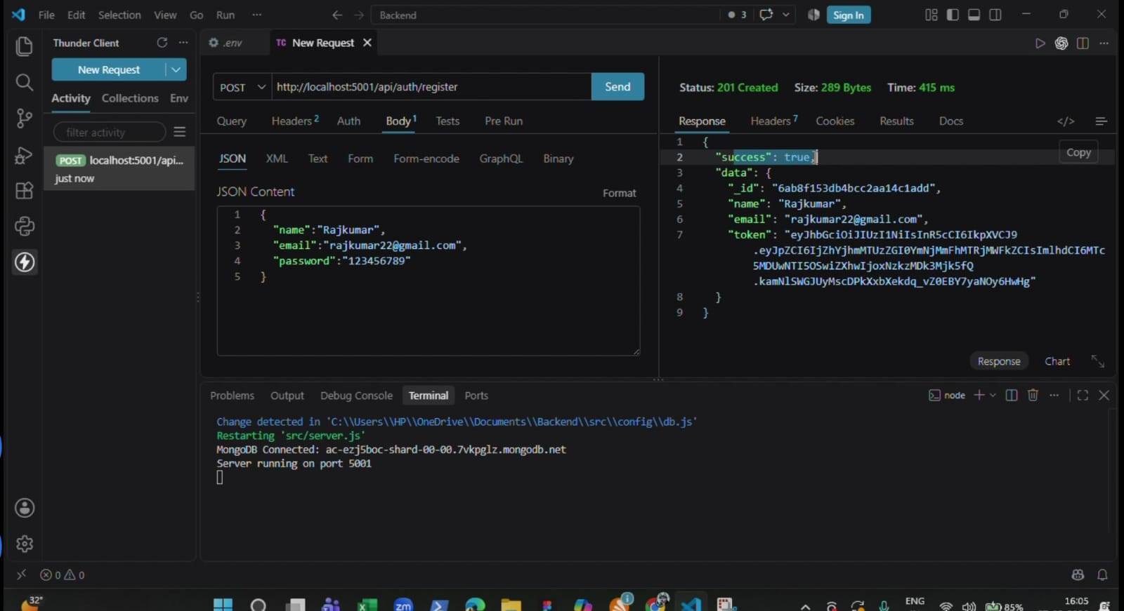
The supplied demo video shows the backend running locally in Visual Studio Code and API requests being tested using Thunder Client. The demonstration includes authentication, weather retrieval and AI-powered endpoints. Register API

10.2 Login API
The login request successfully returned an authentication response containing a JWT token. This demonstrates the authentication flow used for protected requests.
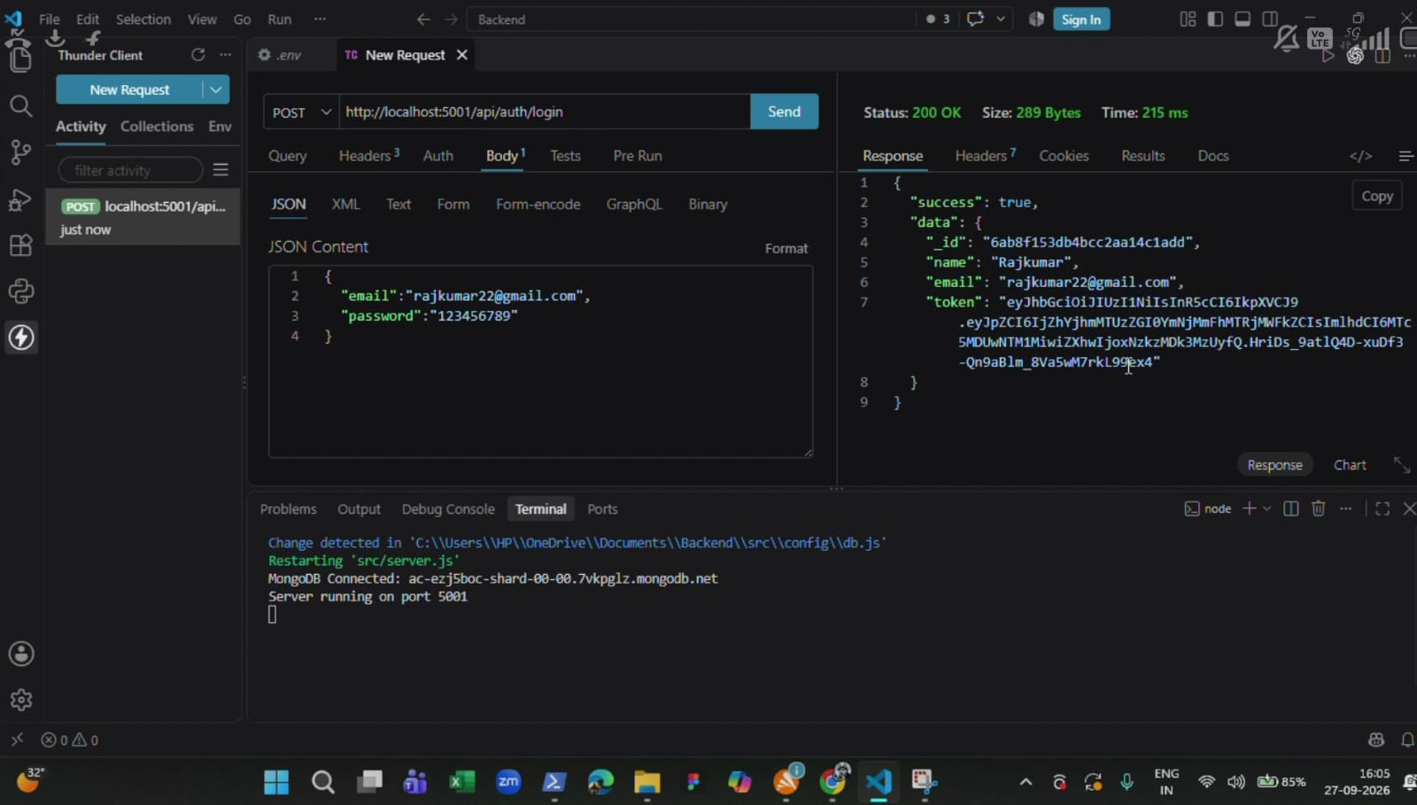

10.3 Testing Note
The demo verifies that the backend can receive requests and return structured responses through the API testing client.

11. Weather and AI Demonstration Results

11.1 Weather API Test
The demonstration shows a successful weather response for Chennai containing weather-related fields such as temperature, humidity, wind speed, condition and is Mock.
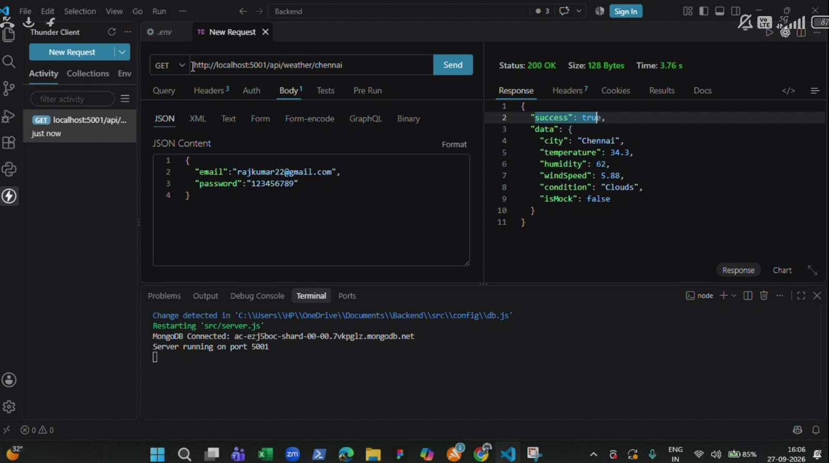

11.2 AI Summary
The AI summary endpoint returns natural-language information derived from the weather values.

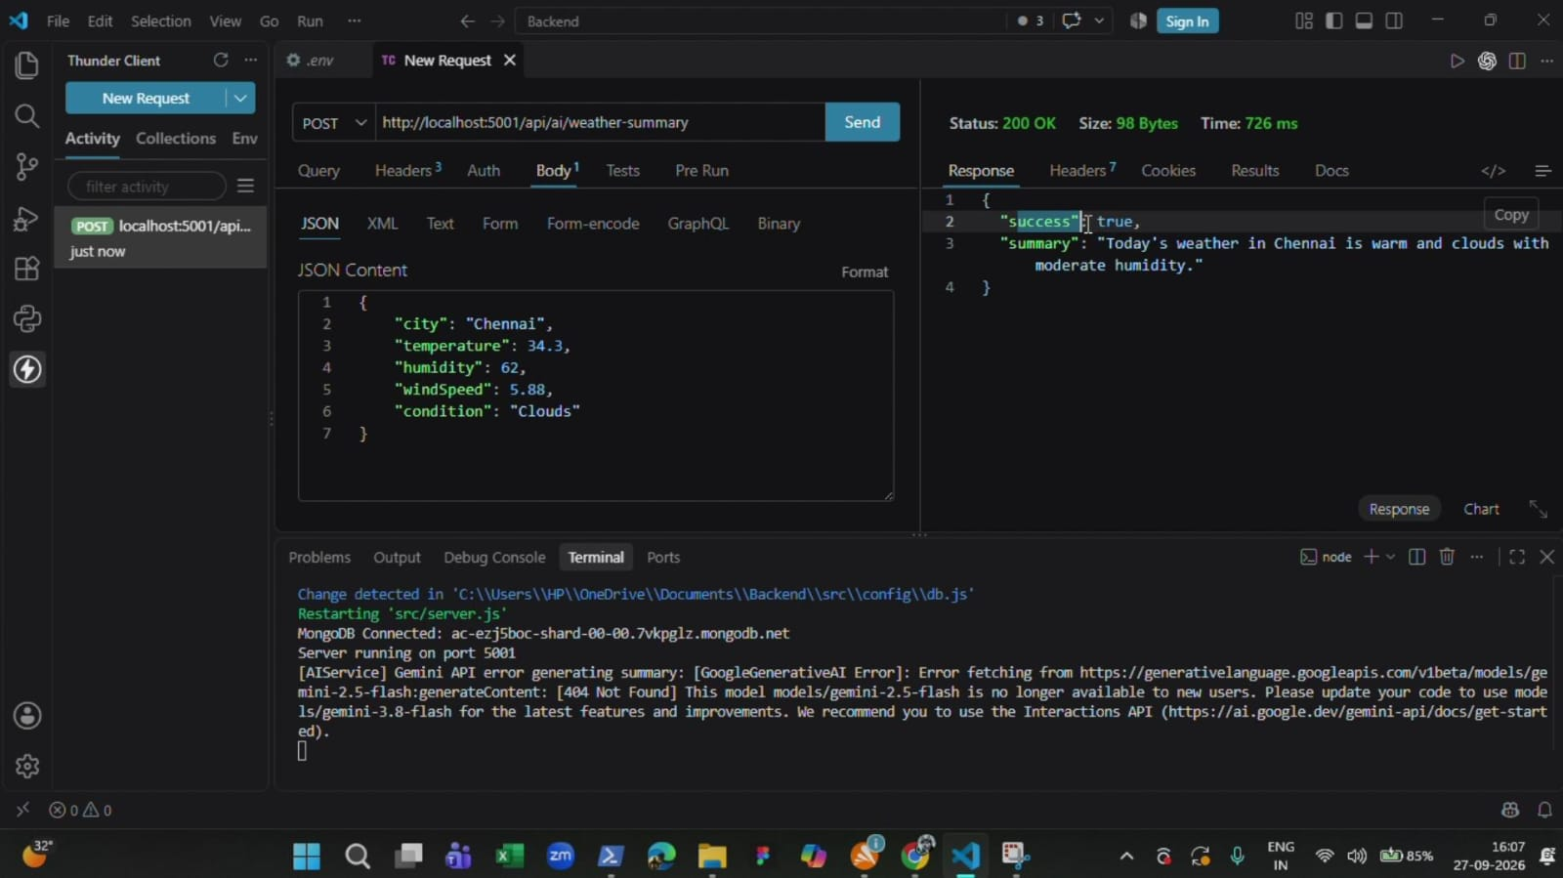

12. Recommendation, Testing and Results

12.1 Recommendation API
The recommendation endpoint returns practical guidance based on the weather information. The project demonstration shows the recommendation workflow through the API testing client.

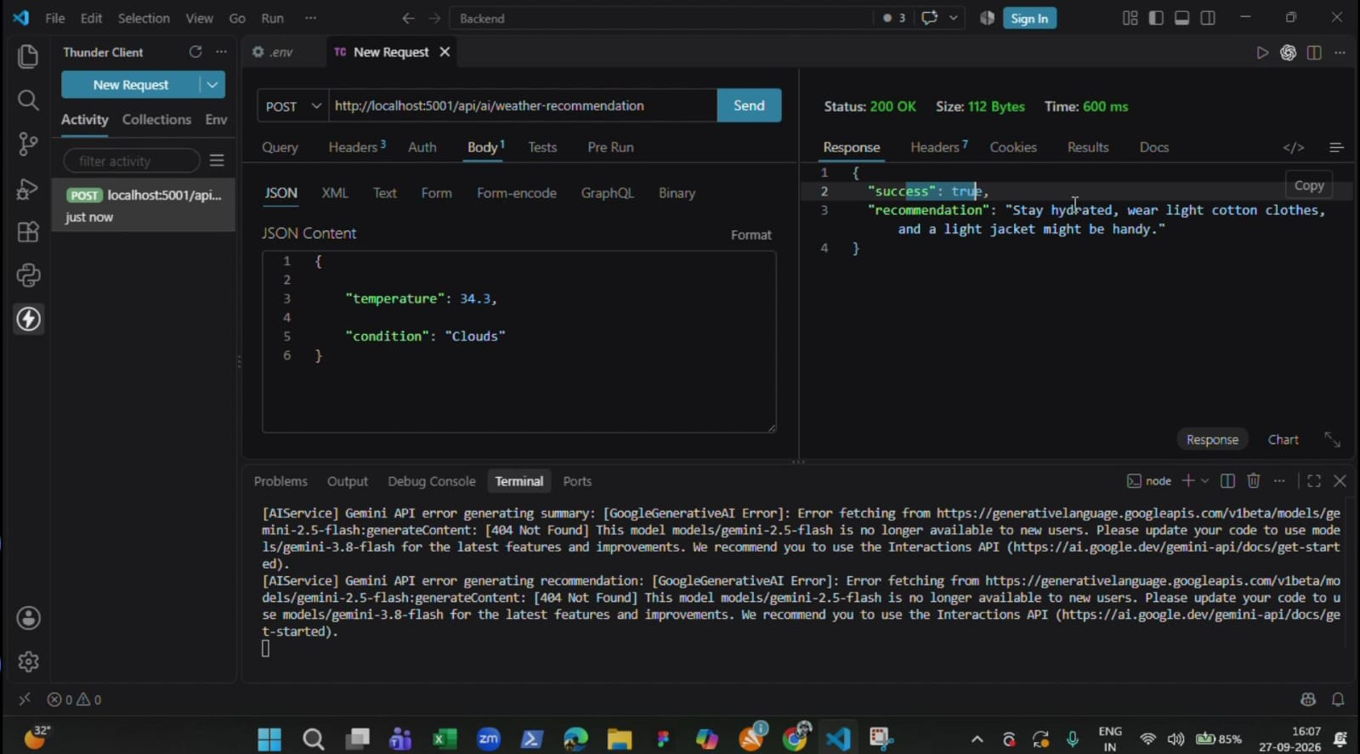

12.2 Test Observations
- Backend server was running locally during the demonstration.
- MongoDB connection status was visible in the terminal.
- Login returned a JWT token.
- Weather endpoint returned structured weather values.
- AI summary returned natural-language weather information.
- Recommendation endpoint returned actionable advice.

12.3 Limitations Observed
- The demonstration is mainly backend/API oriented; a complete end-user UI is not shown.
- An AI model/API availability issue appears during one part of the demonstration.
- The written reference uses port 5000 while the demo shows local execution on port 5001.

13. Security, User Flow and Future Enhancements

13.1 Security and Reliability
- JWT tokens identify authenticated requests.
- Passwords are intended to be hashed using bcrypt/bcryptjs.
- Protected routes validate authentication before access.
- Payload sanitization helps reduce unsafe request input.
- Environment variables keep secrets outside source code.
- Separate routes, controllers, models and services improve maintainability.

13.2 User Flow
- Register or log in.
- Receive an authentication token.
- Save a favourite city.
- Request current weather.
- Review weather metrics.
- Request an AI summary.
- Request practical recommendations.

13.3 Future Enhancements
- Responsive web/mobile interface.
- Hourly and multi-day forecast visualization.
- Weather alerts for severe conditions.
- GPS-based location and improved favorites.
- Expanded AI advice for travel and daily planning. • Historical weather analytics.
- Caching, automated tests and cloud deployment.

14. Conclusion and References

14.1 Conclusion
WeatherWise AI demonstrates how a RESTful backend can combine weather data, secure authentication, MongoDB persistence and AI-generated insights. The project focuses on converting raw weather information into understandable summaries and practical recommendations. The supplied demonstration confirms the main backend workflow through API testing.

14.2 Project Materials
- Supplied reference document: “AI WeatherWise - Deliver intelligent weather forecasts and insights.” • Supplied WeatherWise AI project demo video.
- Node.js and Express.js configuration described in the reference.
- MongoDB and Mongoose data model described in the reference.
- Google Gemini AI integration described in the reference.

API Testing Demo:
https://drive.google.com/file/d/1RVddmSh4nT7HDHNT48jatj5c-6GEQ5nk/view?usp=drivesdk

